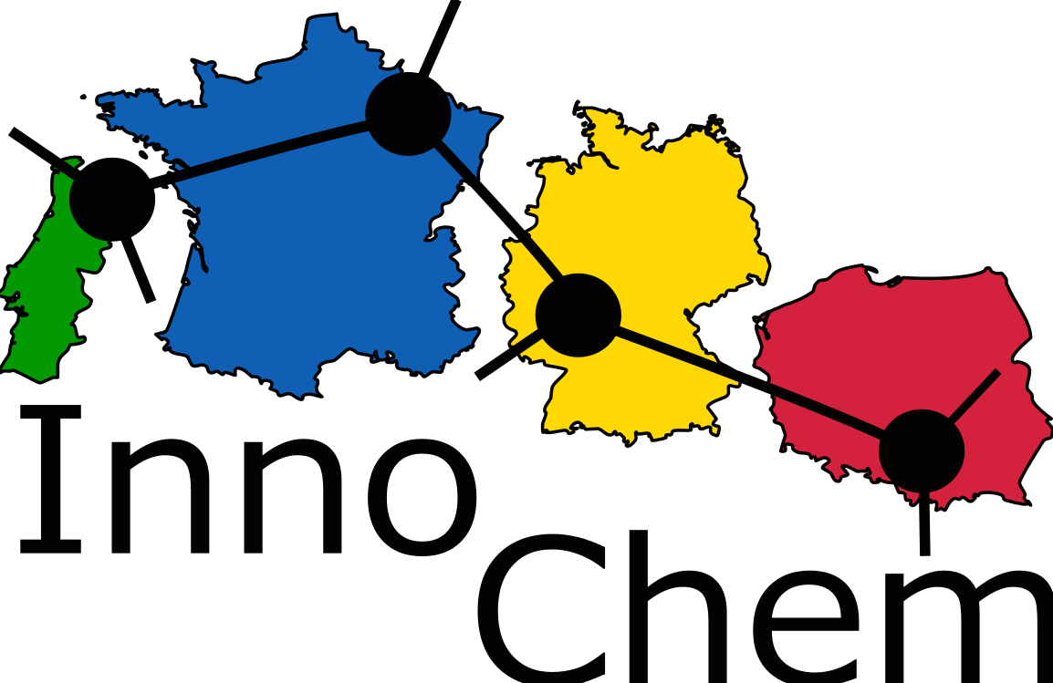

CONFERENCE REGISTRATION FORM
InnoChem
4 July 2017, Krakow, Poland

Please fill in this form and send it to: jzelazny@pk.edu.pl
by 31st May 2017.
(one registration form for each person attending the conference)

Name of partner organization:
Name of participant:
Nationality of participant
Gender
E-mail:
Title of presentation
Poster or oral presentation | __Yes ___No
Gala dinner | __Yes ___No
Hotel Lenart | __Yes ___No
Date of arrival
Date of departure

Accommodation
We provide accommodation for 2 nights on July 3 and 4, 2017 (2 persons in a double room) and sustenance during the conference day.
Name of the hotel: LENART
Address: ul. G. Narutowicza 1, 32-020 Wieliczka
Telephone number: +48 12 32 83 100

e-mail: info@hotellenart.pl
web site: http://hotellenart.pl/

Hotel Lenart is located 2 min. walk from the train station Wieliczka-Park.
Travelling by train is the fastest way to get to-/from the airport (ex. the journey to the city center takes about 20 min., to airport 40 min.).

